Detailed Model Description

Macrophages

In our model, we will simulate two phenotypes of macrophages. M1 macrophages are most prevalent in the inflammatory stage of healing, and the M2, representing all its sub-phenotypes, prevelant in ECM formation and non-inflammatory phases (in older literature “classic” vs “alternative”). M1 are pro-inflammatory, they secrete TNFa, IL6, and IL1 (Murray and Wynn, 2011), and are activated in vitro by LPS and other pro-inflammatory cytokines (Krzyszczyk, 2018). For reasons of tractability, we will group all the M2 phenotypes into one category (as is common in literature), these macrophages produce anti-inflammatory cytokines and are involved in the proliferation phase, as well as, acting as a long-lasting source of fibroblast attracting cytokines, in the second phase of inflammation (Tepole, 2016). They secrete TGFb and IL10. In the future M2b macrophages (regulatory) are prime candidates to represent the intermediate stage between the phenotypes, as they secrete TNFa, IL1, IL6, and IL10. Both phenotypes can be responsible for wound healing disruption, if M1 do not modulate, the inflammation phase lasts too long and thus the wound becomes chronic (Tepole, 2016; Koh and DiPietro, 2011; Krzyszczyk et al., 2018). This can result from a misbalanced cytokine or hypoxic micro-environment (Faulknor et al., 2017). Neutrophil clearance (phagotysis) can also causes the phenotypic switch to M2b, leading to the resolution of inflammation (Filardy et al., 2010; Hesketh et al., 2017). Whilst the excessive action of M2 macrophages results in “excessive collagen formation, resulting in scarring” (Sindrilaru and Scharffetter-Kochanek, 2013; Vannella and Wynn, 2017).

“The prolonged presence of the M1 phenotype is not the only macrophage-related problem that can contribute to wound healing disruption. In fact, if M2-like macrophages remain for too long, there may be excessive collagen formation, resulting in scarring (Sindrilaru and Scharffetter-Kochanek, 2013; Vannella and Wynn, 2017).”
- M1 – These macrophages are pro-inflammatory and “abundant and persistent in chronic wounds”. They secrete TNFa, IL6, and IL1 (Murray and Wynn, 2011), and are activated in vitro by LPS and other pro-inflammatory cytokines (Krzyszczyk, 2018). “This highly phagocytic behavior, serve the role of sanitizing the wound and clearing it of dead tissue”.
- Modulation: In hypoxic environments, macrophages do not display M2 characteristics, in normoxic they do (Faulknor et al., 2017). Also “The act of neutrophil clearance by macrophages can induce the phenotypic switch of M1 macrophages to M2b, and lead to the resolution of inflammation (Filardy et al., 2010; Hesketh et al., 2017).”
- M2 –
- In humans, at homeostasis, ∼85% of blood monocyte are classical, 5% are intermediate and 10% are non-classical (Italiani and Boraschi, 2014).
- Macrophages act as a long-lasting source of fibroblast attracting cytokines, in the second phase of inflammation (Tepole, 2016).

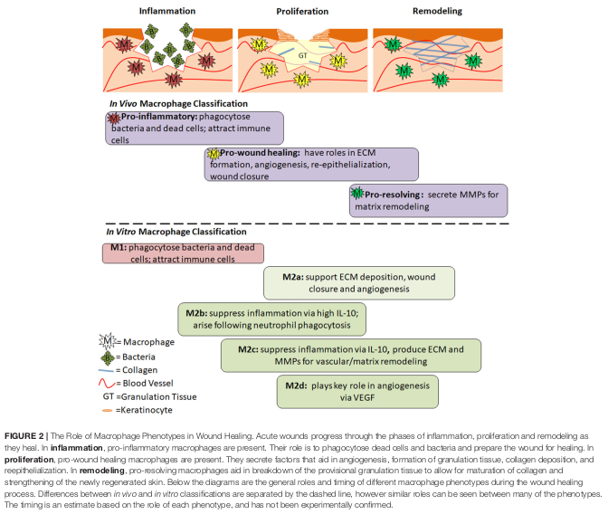

Fig 1. Our model uses this schema to differentiate macrophage phenotypes, it is far from perfect but does allow us to bridge gap between inflammation and proliferation within the same model (Krzyszczyk, 2018)

Macrophages in the Model

- In the DFU model, macrophages last about 4-6 days (~120 timesteps).
- 85-90% of initial value represent M1 (from HIIS), the value is hardly affected by supplemented AP and therefore it is their phagocytic, modulation, and secretion behaviour in the model which is most of interest.
- Movement – Can only move into endothelial cells with oxygen content above a threshold (as of now 20%) and below a threshold of collagen (as of now 100%, 1200 micrograms per mm^3). Therefore random walking over areas of inflammation, when encountering apoptotic neutrophils (low energy) they will remove this. *Not decided how many/much apoptotic cells are cleared*
- Phagocytic Behaviour – Not included in the DFU model, we will have to implement our self …
- Modulation -
- Secretion – All macrophages secrete the most to their current cell, and less to their neighbourhood. M1 – TNFa and IL6. M2 – TGFB and IL10.

Initial: Values in non-coagulated zones from HIIS (85% M1, 15% M2).

- Resting macrophages attracted to tissue with high TNFa and low IL10.
- if neighbourhood has apoptotic neutrophil && M1, move and phagocytsed
- else random walk
- If M1: if high IL6 & TNFa modulate to M2. Else secrete IL6 & TNFa & heal endothelial cell. Lose energy
- IF M2: secrete IL10 and TGFB. Lose energy
- Go to 2.

Neutrophils

The primary function of neutrophils is to prevent infection in the wound, sterilising and killing potentially pathogenic cells but can also cause tissue damage that delays healing and causes excessive scarring (Wilgus et al., 2013). They are the first cells to be recruited, and resolve inflammation through apoptosis and secreting proteases and pro-inflammatory mediators (mainly MMPs and other proteases we haven’t modelled). Neutrophils undergo apoptosis after they have performed their inflammatory function, and are eventually engulfed by macrophages. If this happens too soon, or there is excessive phagotysis, the inflammatory signal will not be sufficient and may result in unresolved inflammation (Wilgus et al., 2013).

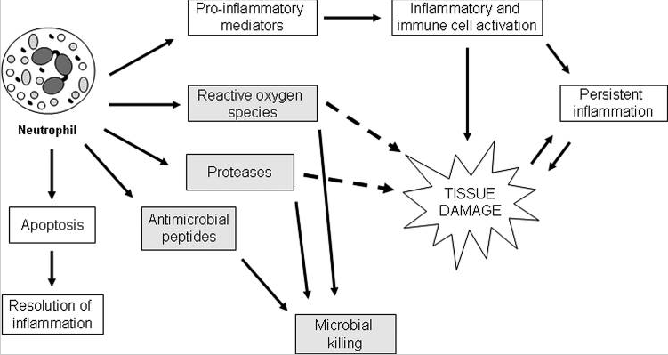
While neutrophils are an integral part of the inflammatory response and can secrete signals which amplify inflammation at the early stages of healing, recent evidence suggests that these cells also act as a signal to shut down the inflammatory phase of healing. In a normally healing wound, neutrophils undergo apoptosis after performing their function at the wound site. Apoptotic neutrophils are eventually engulfed by macrophages, and the uptake of apoptotic cells by macrophages provides a strong signal for the resolution of inflammation.

- In the DFU model, neutrophils last 1-3 days (~48 timesteps)
- Apoptotic Neutrophils that are not phagoctysed by macrophages become necrotic and pro-inflammatory, also caused by macrophages having reduced apoptotic clearance activity (Khanna et al., 2010)
- Should the neutrophils stay at site of inflammation until resolved? Or continue random-walking?

Initial: Values in non-coagulated zones from HIIS.

- Resting neutrophils attracted to tissue by IL6 and TNFa in endothelial cells +
- Random walk
- Heal oxy
- Secrete TNFa
- Lose Energy (IL10 exacerbates)
- If energy < 0 become apoptotic for ~5 hours, if not phagoctysed (by M1??) become necrotic and mini burst of TNFa and reduce oxy
- Back to 2

Fibroblasts

Fibroblasts are attracted to the wound site, from the edge of the wound, by chemoattractants such as TGFB and TNFa (released by macrophages), (Bainbridge, 2013). In the presence of TGFB they undergo a phenotypical change, fibroblasts start to attach to the ECM and express fibrins and collagen. They also show increased collagen deposition in the presence of TGFB (Tepole, 2016). Oxidative stress may also drive uncontrolled fibroblast proliferation and keloid formation (Eming, 2004). Scar tissue is characterised by thinner collagen bundles with a higher degree of alignment (Grant et al., 2012), whilst regeneration is characterised by “Basket-weave” collagen deposition.

- “Basket-weave” collagen deposition is considered to be healthy while parallel deposits are scars.
- Oxidatvie stress may drive uncontrolled fibroblast proliferation and keloid formation (Eming, 2004) [Fibroblasts attracted by too much TNFa???].
- Fibroblasts show increased collagen deposition in the presence of TGFB (Tepole, 2016).
- Scar tissue is characterised by thinner collagen bundles with a higher degree of alignment (Grant et al., 2012).
- Our model does not consider the remodeling of the ECM that occurs after the depositing of the ECM, can we approximate this easily? Probably less fibrosis than our model would simulate?
- Fibroblasts migrate from the edge of the wound following a wound.

Variable: Collagen stock

- Source of fibroblasts at edge of wound (healthy skin, stem cell / hair follicles)
- They can only migrate once the non-coagulated wound area has over 95% of potential oxygen content
- If collagen of current cell > 100, move (attracted to TGFB) (lose less energy)
- Else deposit collagen according to TGFB and IL6 (multiplied by “collagen stimulation factor”) and lose energy
- Secrete TGFB, (IL6, TNFa)
- Back to 3

Endothelial Cells

Each endothelial cell is also a spatial area (or micro-environment). Whilst there is only one layer of endothelial cells, collagen and cytokines levels are stored in each cell, meaning the ECM is implicit in this layer, given that the interaction dynamics are operating at different levels of abstraction, it approximates the multi-level wound healing process (i.e. once inflammation is cleared and the right micro-environment is established, fibroblasts can proliferate, collagen can then start to accumulate on the “top” layer).

- Wound signal is released from the wound edge for 30 minutes and diffuses at 200 μm2/min (Weavers et al., 2016).

Initial: At the start of simulation, endothelial cells are given an oxygen content according to their distance from the centre, level of coagulation, and prescribed zone (e.g. coagulation, stasis, and hypermia).

- Endothelial cells calculate if resting neutrophils and macrophages should be attracted and activated
- Keeps track of cytokine concentrations and oxygen level (decays and variable changes)

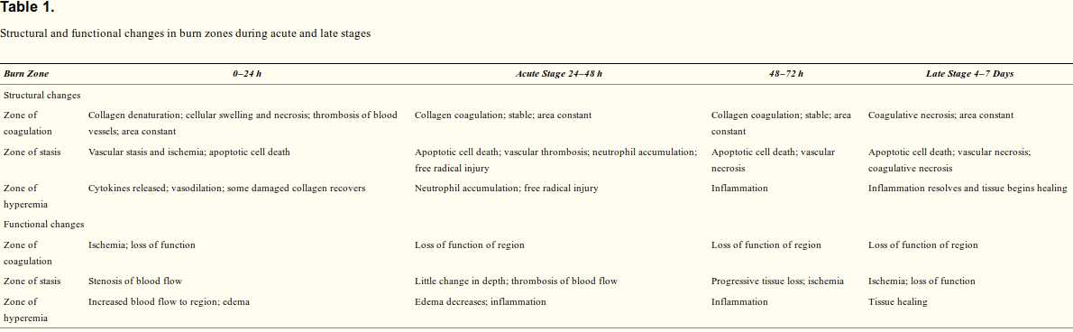

Cytokines

- Cytokines (particularily IL6 and IL10) are distributed at the start of the simulation according to blood exposure (oxygen content in endothelial cells) according to the body’s response boundaries (Thatcher et al., 2016).

Deregulation of key pro-inflammatory cytokines (IL1B and TNFa) prolong the inflammatory phase (Eming, 2004).

Initial: Values in non-coagulated zone from HIIS.

Extra Notes on Li Paper

The Li model was based on laryngeal secretions following trauma (inflammation), so only give insight into the “net effects” (non-spatial).

Platelets, neutrophils and macrophages.

Platelets produce TGFB1 which chemoattracts both neutrophils and macrophages.

Activated neutrophils and macrophages secrete pro-inflammatory mediators, which in turn induce anti-inflammatory mediator release . ??? From where???

Pro-inflammatory mediators also induce neutrophils and macrophages to produce “free radicals” that damage tissue. Free radicals “subsumed” ?replace? By TNFa.

Anti inlammatory mediators cause fibroblast activation.

Fibroblasts secrete collagen that mediates tissue repair, collagen accumulation is used as surrogate for healing outcome.

This model grades the state of the tissue from basal to stressed to damaged. (Much like our body response zones in wound healing)

Pattern-oriented analysis used : We could establish burn wound comparison conditions ??

- Phagocytic behaviour of macrophages after eating neutrophils? Do they dissapear? Do they modulate to M2, do they continue clearing neutrophils?

